**IRS Mandate Requirements**

**1099 MISC & NEC Forms**

**Tax Management and Reporting System**

**V3.0**

**05/12/2020**

**Sarah Combs**

**1099 MISC Form Requirements**

**Purpose**

The purpose of this project is to implement the changes required to meet the IRS 2020 mandate for the 1099 MISC form as listed below.

* The 1099 MISC substitute form will only be used to report casino winnings and sweepstake winners; travel agency commissions will be reported on the new 1099 NEC (non-employee compensation) form.
* Winnings will be reported in Box 3 Other Income (previously reported in Box 7)
* Label / Field changes (outlined in this document)

**Assumptions**

* No changes are required to the letter template that is currently used for the 1099 MISC substitute form (a new letter template will be created for the 1099 NEC substitute form)
* Boxes 11 through 17 will not be included in Carnival’s version of the 1099 MISC substitute form
* As of the date of this document, there are no changes required to the IRS file

**Current IRS 1099 MISC Form**

**1099 MISC** substitute form “customized” by CCL and currently provided to travel agencies for earned commission and to guests for casino and sweepstakes winnings.

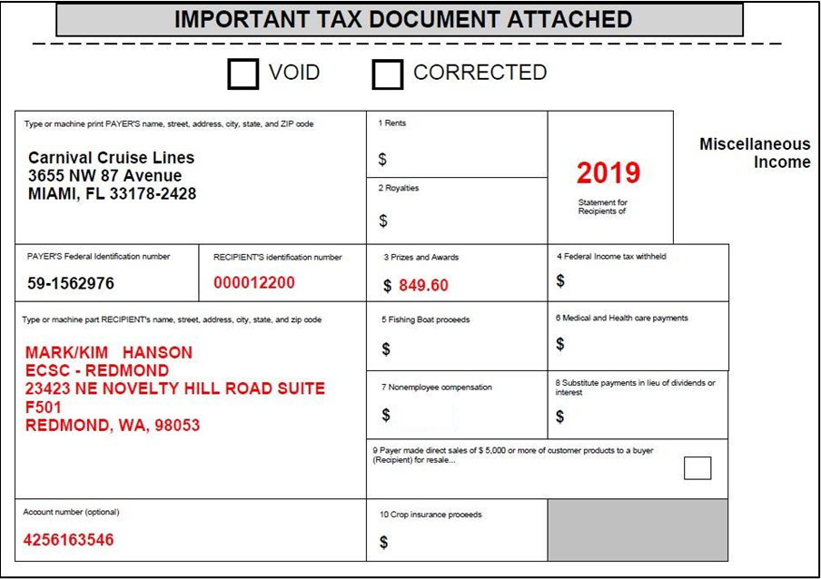

**New IRS 1099 MISC Form**

**New 1099 MISC** form to be used for casino winnings and sweepstake winners only; will no longer be used for travel agency commissions. Travel agency commissions will be reported on the new 1099 NEC (non-employee compensation) form.

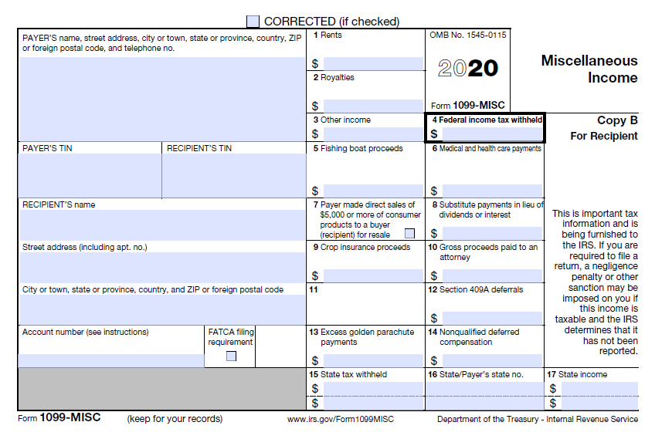

**1099 MISC Substitute Form (Carnival Version)**

|  |  |  |  |
| --- | --- | --- | --- |
| **Box No.** | **Current 1099 MISC Field / Label** | **New 1099 MISC Field / Label** | **Notes** |
| N/A | Void | Void | No changes to these fields for the new form |
| N/A | Corrected | Corrected |

|  |  |  |  |
| --- | --- | --- | --- |
| **Box No.** | **Current 1099 MISC Field / Label** | **New 1099 MISC Field / Label** | **Notes** |
| N/A | (Tax Year) followed by "Substitute for Recipients of" | (Tax Year) followed by "Statement for Recipients of" | No changes to these fields for the new form |
| N/A | Miscellaneous Income | Miscellaneous Income |

|  |  |  |  |
| --- | --- | --- | --- |
| **Box No.** | **Current 1099 MISC Field / Label** | **New 1099 MISC Field / Label** | **Notes** |
| N/A | Type or machine print PAYER'S name, street address, city, state and zip code | PAYER'S name, street address, city, state and zip code | The new field label will **not** include:   * Type or machine print * Town, Province, Foreign Postal Code, Telephone No. |

|  |  |  |  |
| --- | --- | --- | --- |
| **Box No.** | **Current 1099 MISC Field / Label** | **New 1099 MISC Field / Label** | **Notes** |
| N/A | PAYER'S Federal Identification number | PAYER'S TIN |  |
| N/A | RECEPIENT'S Identification number | RECEPIENT'S TIN |  |

|  |  |  |  |
| --- | --- | --- | --- |
| **Box No.** | **Current 1099 MISC Field / Label** | **New 1099 MISC Field / Label** | **Notes** |
| N/A | Type or machine print RECEPIENT’S name, street address, city, state and zip code | RECEPIENT’S name, street address, city, state and zip code | The CCL version of the substitute form will combine the name and address boxes into one box (same as the previous 1099 MISC form)  The new field label will **not** include:   * Type or machine print * Town, Province, Foreign Postal Code, Telephone No. |

|  |  |  |  |
| --- | --- | --- | --- |
| **Box No.** | **Current 1099 MISC Field / Label** | **New 1099 MISC Field / Label** | **Notes** |
| 1 | Rents | Rents | No change to this field |
| 2 | Royalties | Royalties | No change to this field |
| 3 | Prizes and Awards | Other Income | Winnings will continue to be reported in this box; only the field label has changed |
| 4 | Federal Income Tax Withheld | Federal Income Tax Withheld | This field will not be populated since the system does not currently provide the ability to store withholding tax information |

|  |  |  |  |
| --- | --- | --- | --- |
| **Box No.** | **Current 1099 MISC Field / Label** | **New 1099 NEC Field / Label** | **Notes** |
| 5 | Fishing Boast Proceeds | Fishing Boast Proceeds | These fields are for display purposes only and will always be blank. |
| 6 | Medical and Health Care Payments | Medical and Health Care Payments |
| 7 | Nonemployee Compensation | Payer made direct sales of $5,000 or more of customer products to a buyer (Recipient) for resale |
| 8 | Substitute payments in lieu of dividends or interest | Substitute payments in lieu of dividends or interest |
| 9 | Payer made direct sales of $5,000 or more of customer products to a buyer (Recipient) for resale | Crop insurance proceeds |
| 10 | Crop insurance proceeds | Gross proceeds paid to an attorney |

**1099 MISC NEC Form Requirements**

**Purpose**

The purpose of this project is to implement the new 1099 NEC form that was introduced by the IRS to be used for reporting of nonemployee compensation for 2020 filings and beyond. The 1099 MISC form will no longer be used to report commission earned by travel agencies. Travel agency commissions will be reported on the new 1099 NEC form.

The form that will be implemented is a “substitute” form and has some slight variations to the actual 1099 NEC form published by the IRS as outlined in this document.

As is current practice, the 1099 NEC substitute form will be sent to travel agencies as part of a letter. The changes required to the letter template are also outlined in this document.

**IRS 1099 NEC Form**

**1099 NEC Substitute Form (Carnival Version)**

|  |  |  |  |
| --- | --- | --- | --- |
| **Box No.** | **Current 1099 MISC Field / Label** | **New 1099 NEC Field / Label** | **Notes** |
| N/A | Void | Void | The CCL version of the substitute form will include both fields |
| N/A | Corrected | Corrected | The CCL version of the substitute form will include both fields |

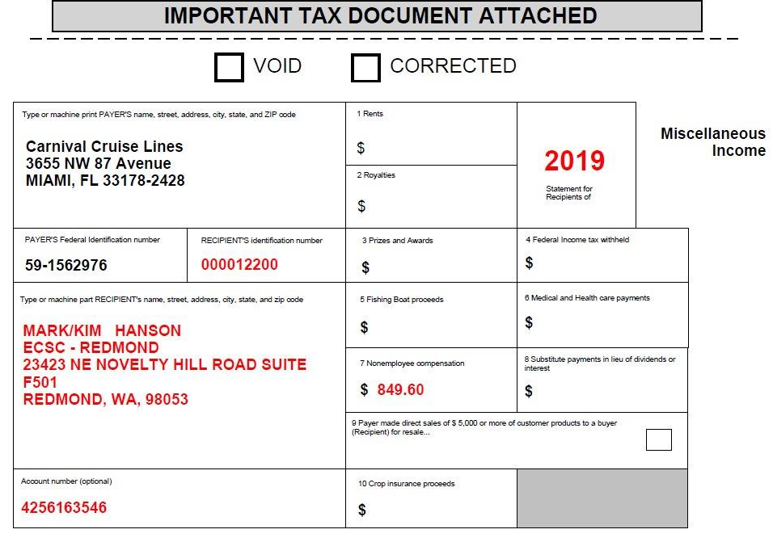 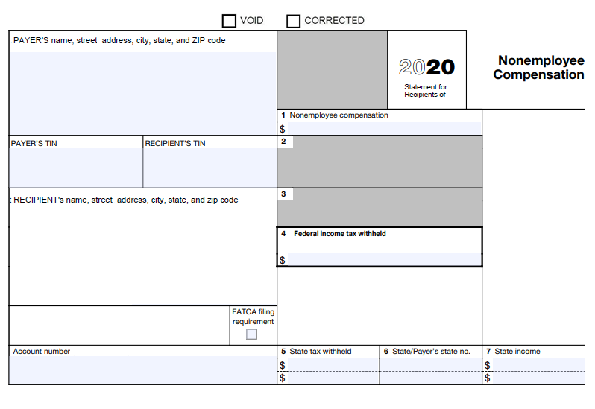

|  |  |  |  |
| --- | --- | --- | --- |
| **Box No.** | **Current 1099 MISC Field / Label** | **New 1099 NEC Field / Label** | **Notes** |
| N/A | (Tax Year) followed by "Substitute for Recipients of" | (Tax Year) followed by "Statement for Recipients of" | No change to this field |
| N/A | Miscellaneous Income | Nonemployee Compensation | New form label |

 

|  |  |  |  |
| --- | --- | --- | --- |
| **Box No.** | **Current 1099 MISC Field / Label** | **New 1099 NEC Field / Label** | **Notes** |
| N/A | Type or machine print PAYER'S name, street address, city, state and zip code | PAYER'S name, street address, city, state and zip code | The new field label will **not** include:   * Type or machine print * Town, Province, Foreign Postal Code, Telephone No. |

 

|  |  |  |  |
| --- | --- | --- | --- |
| **Box No.** | **Current 1099 MISC Field / Label** | **New 1099 NEC Field / Label** | **Notes** |
| N/A | PAYER'S Federal Identification number | PAYER'S TIN |  |
| N/A | RECEPIENT'S Identification number | RECEPIENT'S TIN |  |

 

|  |  |  |  |
| --- | --- | --- | --- |
| **Box No.** | **Current 1099 MISC Field / Label** | **New 1099 NEC Field / Label** | **Notes** |
| N/A | Type or machine print RECEPIENT’S name, street address, city, state and zip code | RECEPIENT’S name, street address, city, state and zip code | The CCL version of the substitute form will combine the name and address boxes into one box (same as the previous 1099 MISC form)  The new field label will **not** include:   * Type or machine print * Town, Province, Foreign Postal Code, Telephone No. |

 

|  |  |  |  |
| --- | --- | --- | --- |
| **Box No.** | **Current 1099 MISC Field / Label** | **New 1099 NEC Field / Label** | **Notes** |
| N/A | Account number (optional) | Account number | No change to this field, currently gets populated with the agency contact number |
| N/A |  | FATCA filing requirement | For display purposes only |

 

|  |  |  |  |
| --- | --- | --- | --- |
| **Box No.** | **Current 1099 MISC Field / Label** | **New 1099 NEC Field / Label** | **Notes** |
| 1 | Rents | Nonemployee compensation | Total earned commission will be reported in this box |
| 2 | Royalties | Blank | Box does not have a label and is grayed out |
| 3 | Prizes and Awards | Blank | Box does not have a label and is grayed out |
| 4 | Federal income tax withheld | Federal income tax withheld | This field will not be populated since the system does not currently provide the ability to store withholding tax information |

 

|  |  |  |  |
| --- | --- | --- | --- |
| **Box No.** | **Current 1099 MISC Field / Label** | **New 1099 NEC Field / Label** | **Notes** |
| 5 | Fishing Boast proceeds | State tax withheld | These fields will not be populated since the system does not currently provide the ability to capture withholding amounts |
| 6 | Medical and Health care payments | State / Payer's state no. |
| 7 | Nonemployee compensation | State Income |

 

**1099 NEC Substitute Form Letter Template**

A new letter template will be created to be used for the 1099 NEC Substitute form. The new letter template will be very similar to the template used today for the 1099 MISC form with the following changes:

1. The reference line (“Re”) should display “Re: Substitute Form 1099 NEC”
2. The first sentence of the letter should read: “Attached is your substitute Form 1099 NEC for Tax Year **2020**. “
3. The current letter template that is used for the 1099 MISC form should be retained since the 1099 MISC form will continue to be used for reporting casino and sweepstakes winnings

